<https://huaban.com/pins/3288311163/>

玻璃文本样式效果

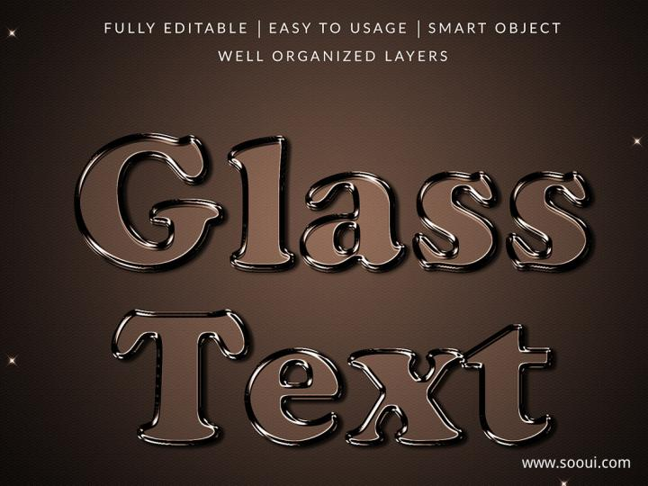

<https://huaban.com/pins/3165148847/>

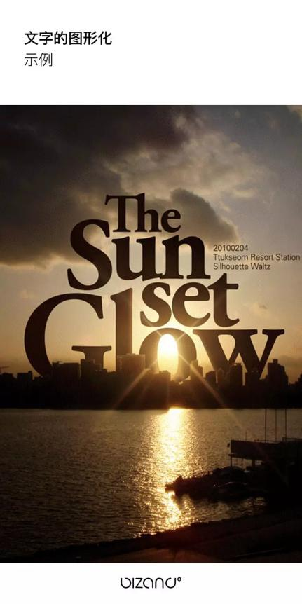

https://huaban.com/pins/3125868135/

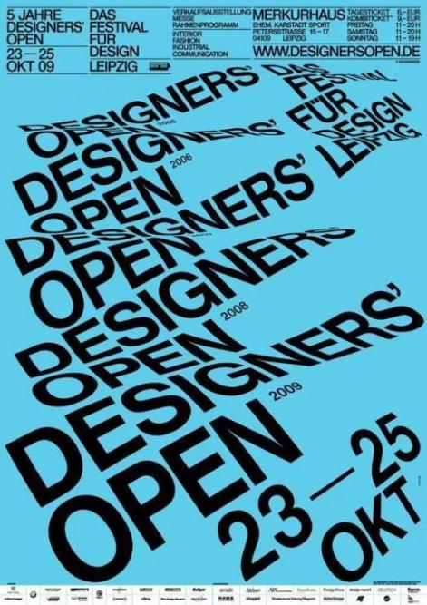

<https://huaban.com/pins/886633618/>

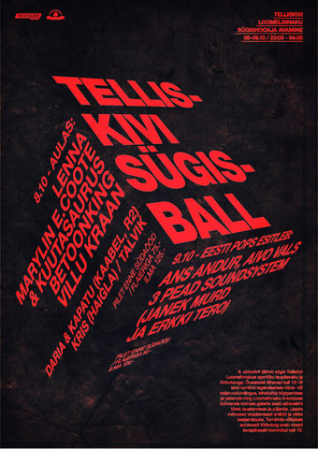

<https://www.bilibili.com/video/BV1jw411d7hX?spm_id_from=333.999.0.0>

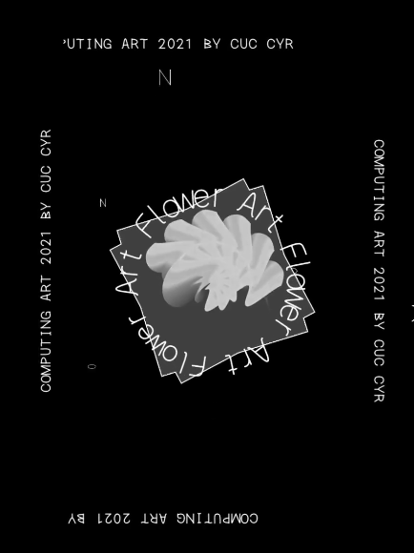

动态字体